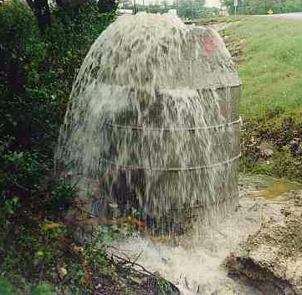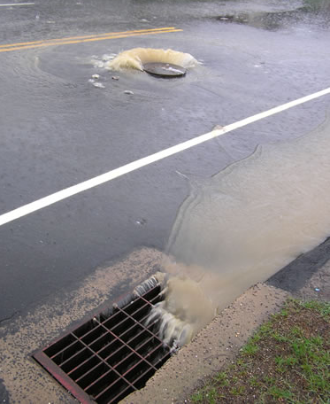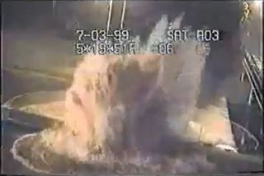

CE-791

SeyedMojtaba Noghabaei

North Carolina State University

CE-791

Pipe Overflow Prediction Model in Stormwater Networks and Visualization Using Mixed Reality

# Abstract

**Objective**: The objective of this paper is to utilize digital twin modeling techniques and prediction models in order to improve visualization and communication for utility managers and predict overflow problems in a stormwater network.  
**Methods**: In order to achieve better communication and visualization for utility mangers and develop overflow prediction models, the researchers in this paper used digital twin models in a Mixed Reality (MR) environment which is connected to a real-time overflow prediction model based on forecasted precipitation or rainfall hydrograph.   
**Results**: The results of this paper was a real-time platform with a very good accuracy i  
**Conclusion**:

Keywords: Mixed Reality; Smart Cities; Digital Twin Model; Artificial Neural Network (ANN); Overflows prediction model

# 1. Introduction

// **[the situation]**

**One of the new and growing technologies in the U.S. and all over the world is smart city technologies. The smart cities technologies can save over $5 trillion for enterprises, governments, and citizens annually over the world (**<http://www.information-age.com/smart-cities-lead-cost-savings-5-trillion-123469863/>**). For example there is a $14 billion saving opportunity for enterprises in areas like more efficient transportation options such as drones, robots or driverless cars and trucks and there is a $5 billion annual saving opportunity for governments using street lighting and smart building technologies. Using smart street lights it is expected to reduce repair and maintenance costs by 30 percent. It is possible to utilize smart city technologies in new areas in order to achieve more savings.**

**// [the problem]**

Many researcher tried to utilize smart cities technologies to achieve more savings in different areas like smart transportation, smart infrastructure, smart Disaster Management System (DMS), and smart visualization. Two areas that still need more developments are smart DMS and smart visualization. Many researchers tried to develop emergency response system in order to reduce costs during a disaster. (A smart disaster management system for future cities), but still there is a big gap between other sections of smart cities and smart DMS. Furthermore, smart visualization technologies can help utility managers to reduce costs as well. (IMMERSIVE DATA VISUALIZATION FOR SMART CITIES))

// overflow problems

Overflow in wastewater and storm water networks is one of the old problems of metropolitans with old networks. Especially in cities like Chicago because of old combined wastewater networks. Detection of these overflows and the reasons behind might be very helpful in post and pre disaster responses.

// smart DMS

// smart visualization

// **[the solution]**

The researchers in this paper tried to develop an overflow prediction model for city of Raleigh and utilized smart visualization techniques by MR technology. They used different ANN models

# 2. Literature Review

## 2.1 Pipe overflow problems

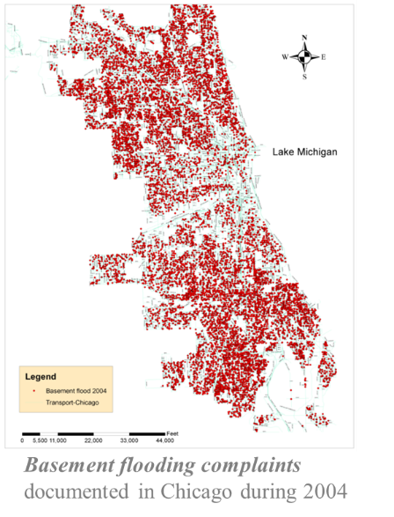

Figure 1: basement flooding complaints documented in Chicago during 2004

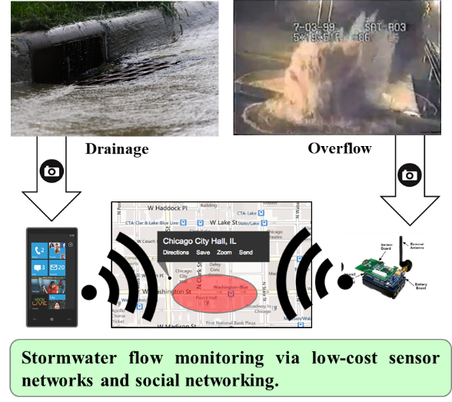

Figure 2: stormwater flow monitoring via low-cost sensor networks and social networking

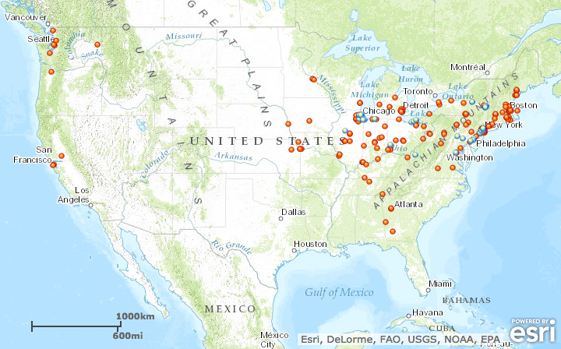

Figure 3: overflow problems across the united states

## 2.2 Data visualization challenges

1. Multidimensional data (e.g., vehicular traffic data) cannot be probed effectively from different aspects (such as "when was traffic data highest" or "How is it related to weather?,"etc.) on a flat screen. To understand their different relations with other data, you need to run analysis multiple times. You, often, forget the previous relations or you do not get a complete picture of a situation simultaneously.

2. The current analysis and visualization platforms do encourage collaboration as stakeholders from different departments such as water and waste management departments from remote locations cannot see and interact the same data simultaneously. Today, cities move by data. Government agencies prevent unwanted incidents, warns citizens beforehand any eventualities and protect them using real-time data insights. Any inefficiencies to handle data not only make the smart cities ineffective but also pose severe risks to citizens’ lives.

3. Imagine there is a leakage with a pipeline at some point. A new engineer goes there and want to dig the ground. He must rely on a 2D static map without any detailed information of equipment installed underneath. He needs to rely on voice-based Instructions from his senior . Though the sensor captures all information about the pipeline, the current platform fails to disseminate critical information to remote workers.

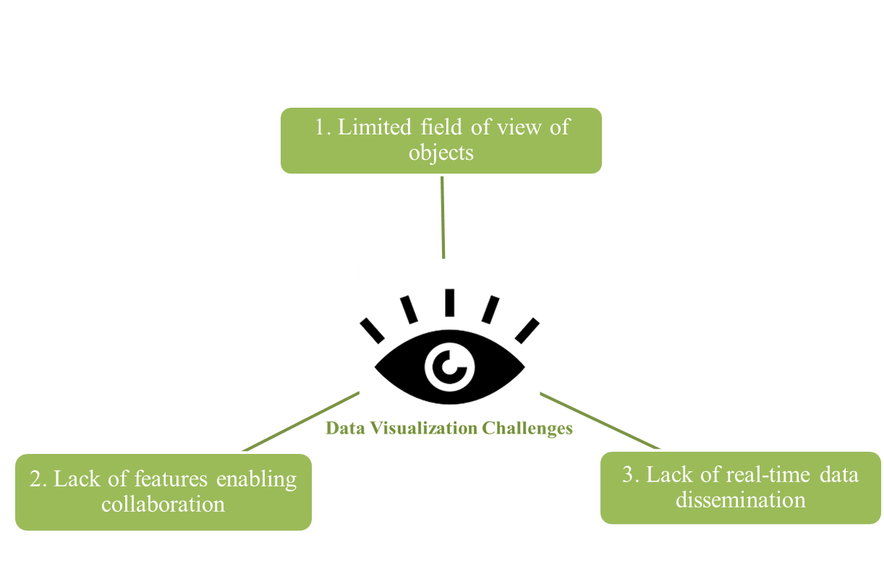

Figure 4: Main data visualization challenges

## 2.3 MR in civil and smart cities industry and other industries

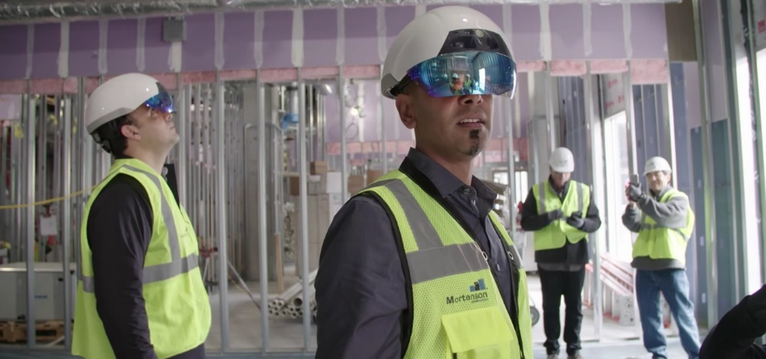

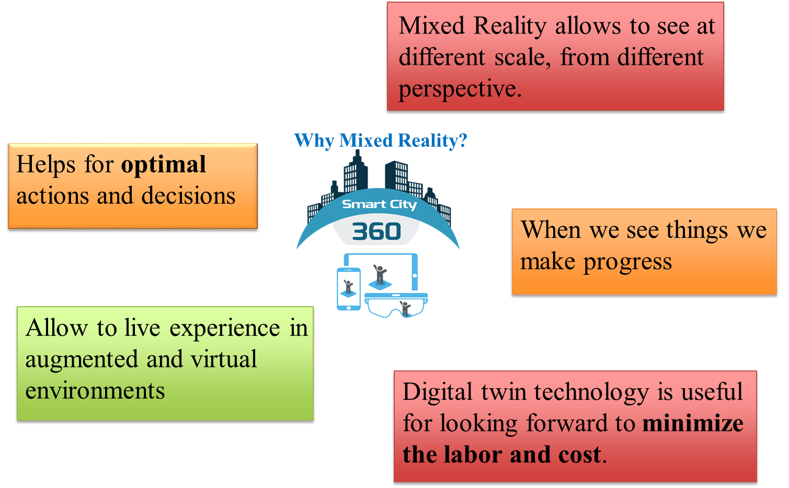

Figure 5: main reasons for using MR as a better approach for visualization

# 3. Research Objectives

The main objectives of this study is to predict pipe overflow problems in Stormwater networks and create a MR digital twin in order to improve visualization and communication between utility managers.

1. Create a platform to predict overflows in order to help utility managers before disasters
2. Create a digital twin for the Stormwater network and enable utility managers for better decision making using Mixed Reality technology

# 4. Method

In order to achieve the objectives, the researchers in this paper used the following approach. At the beginning the researchers 1) gathered the overflow data from Storm Water Management Models (SWMM) for the city of Raleigh. After that the researchers 2) created an artificial neural network model in order to predict overflow positions based on the SWMM data. Finally, the researchers 3) visualized the overflow problems in a MR environment in order to achieve better visualization and collaboration for utility managers.

1. Generate data from SWMM
2. Create models for predicting overflows
3. Visualize in a twin MR model

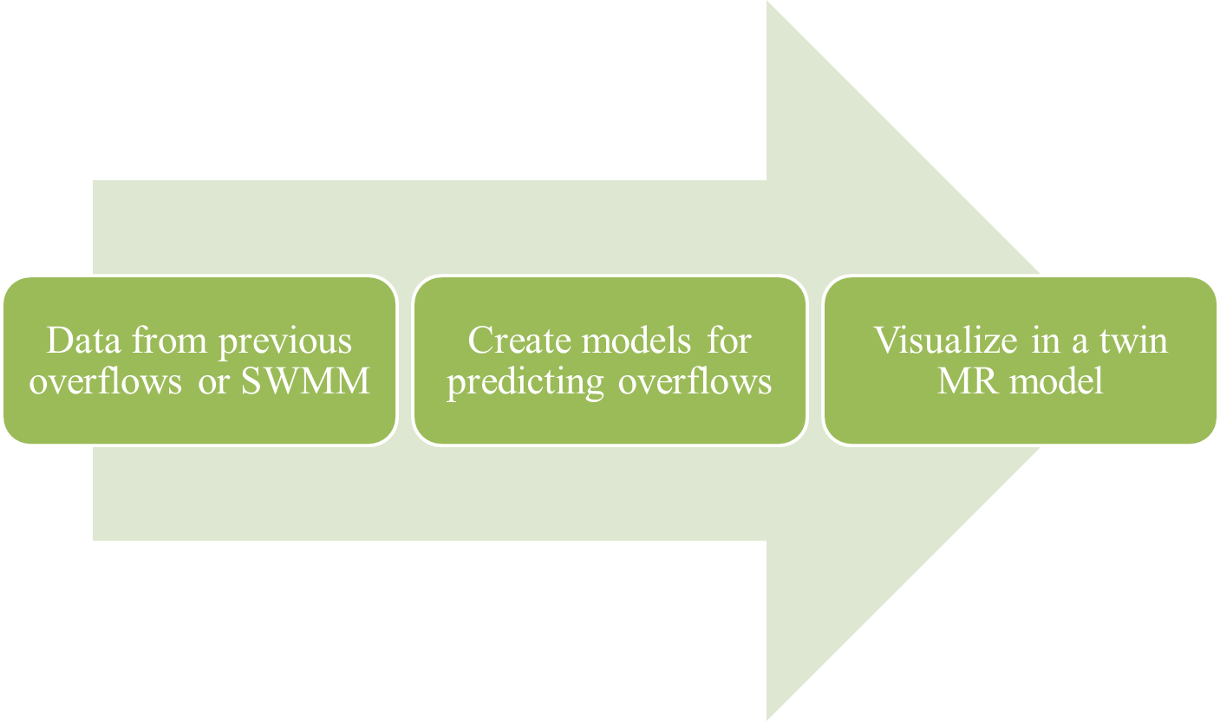

Figure 6: research method main steps

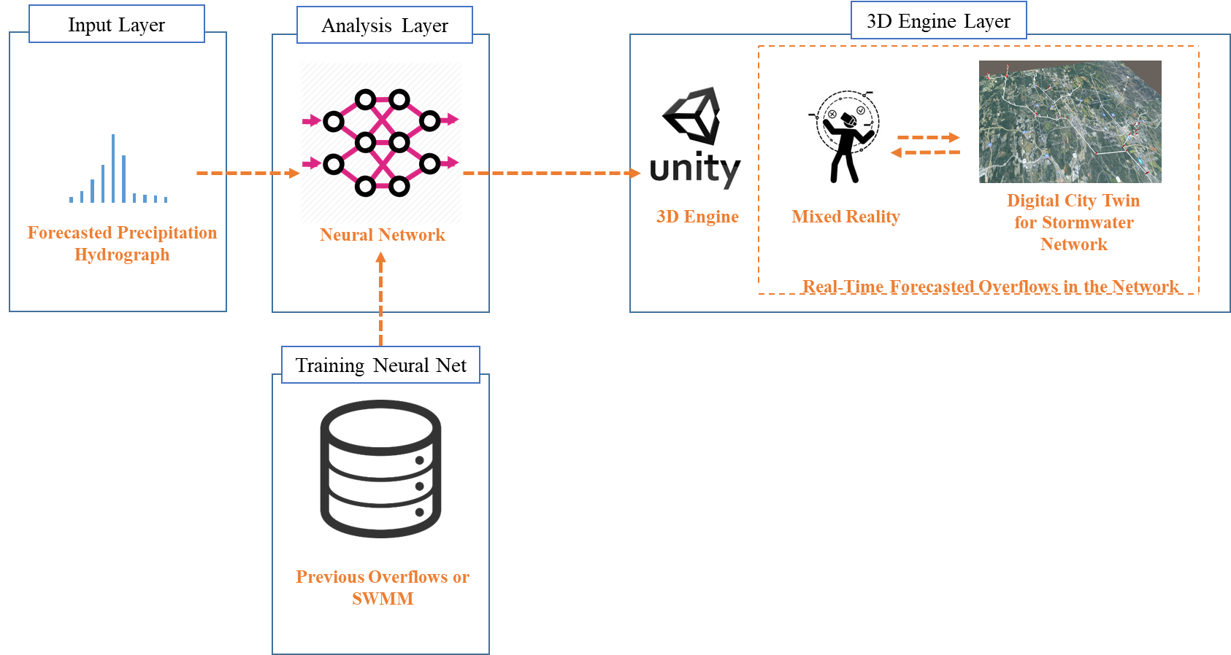

Figure 7: system architecture which represents the prediction model and MR

The system architecture consists of three different layers.

1. Input layers
2. Analysis layer
3. 3D engine layer

**Input layer:**

**Analysis layer:**

**3D engine layer:**

## 4.1 Pipe overflow prediction model

In the following section, the researchers will introduce the data which is used to train neural network and the specifications of the neural network which was used.

### 4.1.1 Data from previous overflows or SWMM

* Run SWMM for 150 of different precipitations and find pipes or junctions with overflow problems
* 5 minute sampling hydrographs
* All data is from city of Raleigh

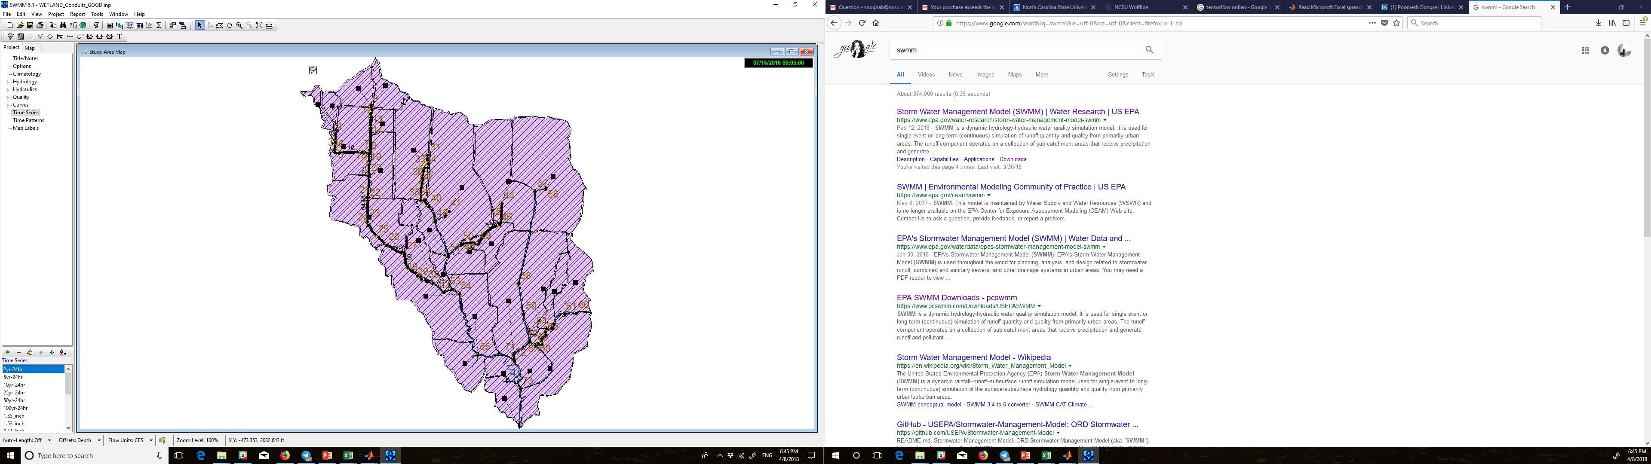

Figure 8: Raleigh stormwater network map

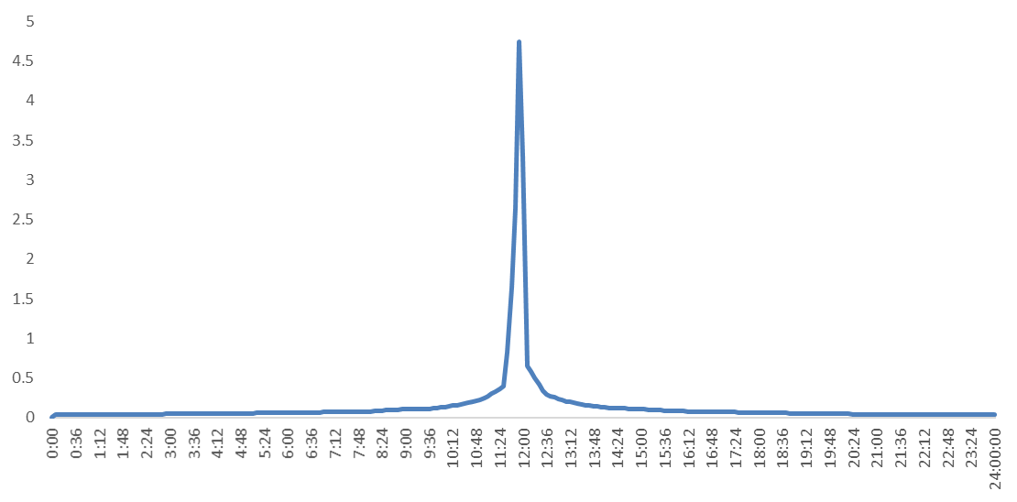

Figure 9: sample precipitation hydrograph

* Precipitation hydrograph (5 min sampling)
* Precipitations with high peak

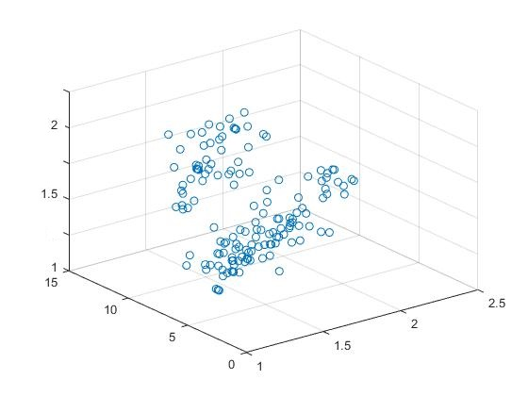

Figure 10: input data distribution

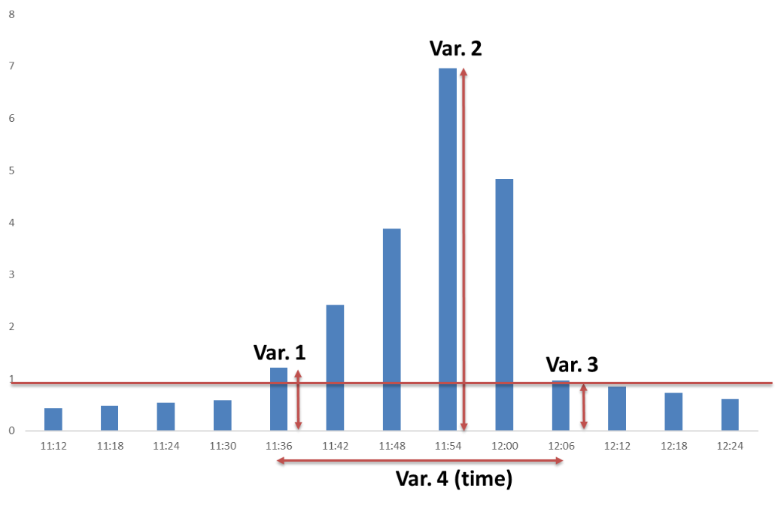

Figure 11: four variables which represent a hydrograph

### 4.1.2 Develop neural network models for overflow prediction

The researcher in this paper used different neural network models and get the best result with neural net fitting approach. The researchers used a neural network with the following specifications.

The neural network consists of 4 input variables as main parameters of a precipitation hydrograph, 3 hidden layers, and 73 outputs which represent 73 junctions in the network. The output values are either zero or one which means flooded or not flooded.

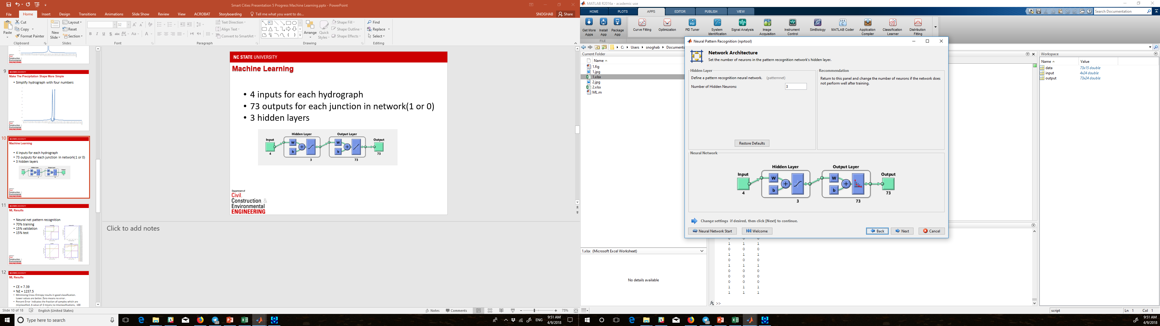

Figure 12: neural network overview

The researcher used 70 percent of total data for training, 15 percent of the data for validation, and 15 percent of the data for test.

### 4.1.3 Data analysis

// investigate the main 3 factors

As a digest of aforementioned hypotheses. The main limitations of VR/AR utilization in construction industry is lack of budget, lack of understanding of upper management, and lack of knowledge of design teams. Finding a solution for these limitation can simply improve VR utilization and customer satisfaction rate.

## 4.2 MR digital twin model

//About the opportunities from surveys

It is possible to use VR models for different purposes in construction like

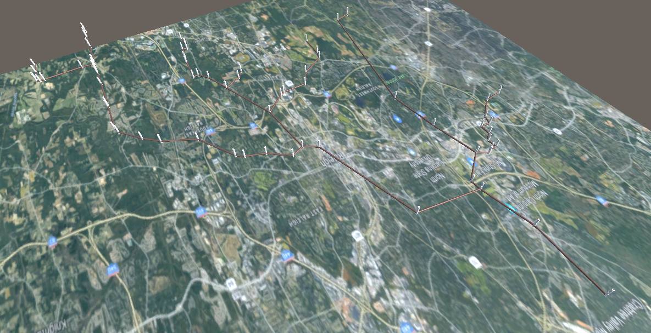

Figure 12: digital twin model of Raleigh stormwater network in MR environment

### 4.2.1 Procedure

// Flow

# 5. Results and Validations

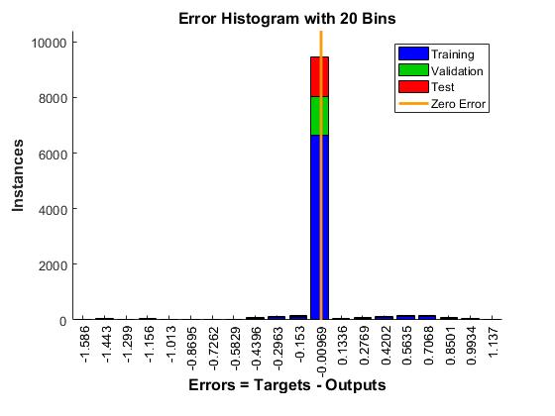

Figure 13: error histogram for the trained neural network

* Real-time over flow prediction platform
* Test a totally new sample with just one misclassification
* The results of this study shows how we can use data collected by sensors to improve management and predict overflows.

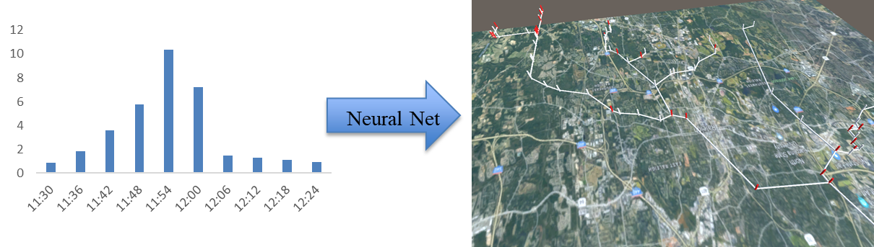

Figure 14: real-time MR environment which can predict overflows and show them by red color

// IMAGE FOR THE MR

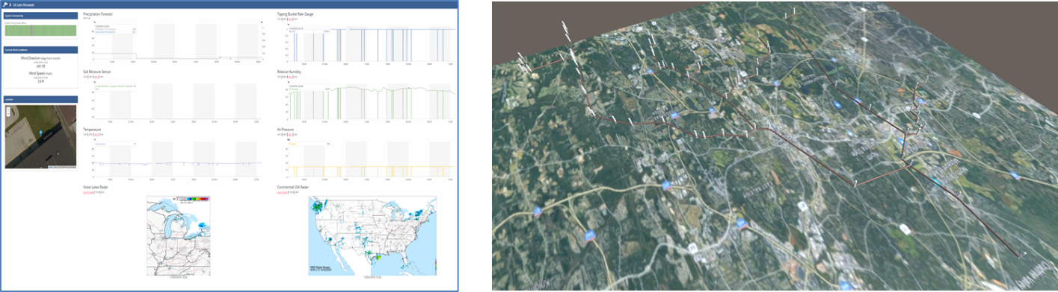

Figure 15: transition from old smart city dashboard into the new MR digital twin model

# 6. Limitations and Future works

## 6.1 Limitations

One of the main limitations of the overflow prediction models is that it cannot detect issues caused by extraordinary events. For instance, if a tree falls into one the conduits in the network, the prediction model cannot predict the upstream overflow for that specific conduit and it may give you false results for the downstream of that pipe.

In addition to the first limitation, this platform cannot give you any recommendation during a disaster. For example if you have 5 teams of technicians that can solve overflow problems and there are 10 different overflow locations, how you can prioritize the overflows. So in these occasions, the utility managers should make a decision based on their experience and the real-time platform cannot help them in decision making process in post and pre disaster responses.

## 6.2 Future works

It is possible to connect several MR devices in order to have a multiplayer experience for utility manager. For instance if one of the managers changes something in the stormwater network, all of the utility managers and technicians can see that change simultaneously. This improvement can cause better communication and collaboration between utility mangers and technicians.

For this paper researchers used data which is generated by SWMM, but it is possible to use previous overflow data in order to achieve more realistic results. The reason behind is using real data can give you better information because the real network might be slightly different from SWMM or even some part of the network might be changed over time.

In order to improve digital twin technology it is possible to combine current stormwater twin models in smart city models. And even generating twin models for other infrastructures like water network, electric network, and gas networks. Having a digital twin model which contains all of the data related to the networks can give utility mangers better visualization and help them in decision making process.

# 7. Conclusion

* Efficient stormwater management
* Rapid and ahead of time response in emergencies
* Efficient disaster management
* We can use this approach in other areas smart cities like traffic, water network, and natural gas network.
* The problem was predict overflow and visualize it in a better way
* We used different types of neural networks and tested them and reported the best one
* Finally we were able to train a neural network model using our data and predict overflow and visualize it in a digital twin model of network

# 8. References